Infrastructure

Sneha Venkatesh

Abstract

The Internet today is a widespread information infrastructure. There are several Wireless technologies existing today for accessing the Internet. This paper focuses on the Infrastructures of some of the wireless technologies such as Wi-Fi, WiMAX and MiFi and addresses the advantages, disadvantages and the future directions of each of these technologies.

1. Introduction

In information technology and on the Internet, infrastructure is the physical hardware used to interconnect computers and users. Infrastructure includes the transmission media, including telephone lines, cable television lines, and satellites and antennas, and also the routers, aggregators, repeaters, and other devices that control the transmission paths. Infrastructure also includes the software used to send, receive, and manage the signals that are transmitted.
In some usages, infrastructure refers to interconnecting hardware and software and not to computers and other devices that are interconnected. However, to some information technology users, infrastructure is viewed as everything that supports the flow and processing of information.
Infrastructure companies play a significant part in evolving the Internet, both in terms of where the interconnections are placed and made accessible and in terms of how much information can be carried and how quickly it can be carried.
The Internet today is a widespread information infrastructure, the initial prototype of what is often called the Global Information Infrastructure. Its history is complex and involves many aspects - technological, organizational, and community. And its influence reaches not only to the technical fields of computer communications but throughout society as we move toward increasing use of online tools to accomplish electronic commerce, information acquisition, and community operations.
The Internet has revolutionized the computer and communications world like nothing before. The invention of telegraph, telephone, radio and computer set the stage for this integration of capabilities [1]. The
Internet is a world-wide broadcasting capability, a mechanism for information dissemination, and a medium for collaboration and interaction between individuals and their computers without regard for geographic location.

Intelligence

Computation

Connectivity
Figure1. Knowledge Advantage
There are several means of accessing the Internet including dial-up, landline, Wi-Fi, satellite and cell phones. Since wireless networking nowadays has become ubiquitous in everyday lives, this paper mainly focuses on the Infrastructures of some of the Wireless networking technologies like Wi-Fi, WiMAX and MiFi.
The popularity of mobile Internet access, third-generation wireless communication, handheld devices, and Bluetooth have made pervasive computing a reality. As shown in the above figure, the ubiquitous computing environment can be saturated with computing, communication capability, intelligence and integration with users so that it becomes a “technology that disappears”. Wireless technologies are evolving day by day. Although the new, third generation (3G) wireless technology has not yet been implemented, leading companies in the industry are already laying the groundwork for fourth generation (4G) technology. Recent technologies not only deal with computation and connectivity but they are also built with an added Intelligence. As examples, this paper discusses a wireless technology called Mi-Fi [Intelligent Mobile Hotspot] which creates its own personal cloud of high speed Internet connectivity and also provides an example of how Wi-Fi connection has been used to build a smart car.

2. Wireless Network

Wireless Network is any type of computer network that is wireless, and is commonly associated with a telecommunications network whose interconnections between nodes is implemented without the use of wires. Wireless telecommunications networks are generally implemented with some type of remote information transmission system that uses electromagnetic waves, such as radio waves to carry the information. Some wireless data networks run over wireless voice networks, such as mobile telephone networks examples include CPDP, HSCSD, PDC-P, and GPRS. Other wireless networks run on their own physical layer networks, utilizing anything from antennas built into handheld devices to large antennas mounted on towers, examples include 802.11, LMDS, and MMDS. A few wireless networks are intended only to connect small devices over short distances, Bluetooth is an example. Table 1 shows the Roadmap of Wireless Technologies.

TECHNOLOGY | PRIMARY USE | CURRENT DEPLOYMENT | FUTURE ROADMAP
802.11a Wi-Fi | In-building wireless networks | Some offices and homes | Will likely phase out in favor of 802.11n and WiMAX
802.11b Wi-Fi | In-building wireless networks | Worldwide hotspots, offices, homes | Already phasing out in favor of 802.11g
802.11g Wi-Fi | In-building wireless networks | Worldwide hotspots, offices, homes | Will continue to grow until 802.11n appears, then eventually phase out
802.11n Wi-Fi | In-building wireless networks | Non-standard "Pre-N" and "MIMO" devices, used mostly in homes | Standards-based equipment
802.16a WiMAX | Metropolitan and rural broadband & VOIP telephony | Pre-standard equipment being used now | Standards-based equipment for fixed site applications by service providers
802.16e Mobile WiMAX | Mobile broadband data & VoIP telephony | NA | Expected deployment in 2008-2010
GPRS | Cellular data and messaging | About 90 countries | Largely built-out; will transition to 2.5G (EDGE) and 3G (UMTS/HSDPA)
EDGE | Cellular data and messaging | About 30 countries | Will continue to grow during transition to 3G (UMTS/HSDPA)
CDMA 2000 1x (1xRTT) | Cellular voice, data, and messaging | About 30 countries | Will continue to grow during transition to 3G (EV-DO)
1xEV-DO | Cellular voice, data, and messaging | About 16 countries | Expected growth to 120 million subscribers as networks build out
1xEV-DO Rev A | Cellular voice, data, and messaging | NA | Will be phased in beginning by many EV-DO providers
WCDMA/UMTS | Cellular voice, data, and messaging | Available in Europe and a few US cities | The only US UMTS carrier (Cingular) will transition to HSDPA; elsewhere should also give way to HSDPA
HSDPA | Cellular voice, data, and messaging | NA | Will start deploying by Cingular in US with real-world speeds around 400-700Kbps
Bluetooth 1.0 | Personal area networking | Worldwide | Will continue to be the standard for many devices
Bluetooth 2.0+EDR | Personal area networking | Products starting to ship now | Devices needing the higher bandwidth will transition to it
UWB | Personal area networking and home media networking | NA | Products expected
Table 1.Wireless Technology Roadmap [8]
2.1 Wi-Fi

Wi-Fi is a wireless technology which is being widely used nowadays. Wi-Fi is short for “wireless fidelity”, and is used to define any of the wireless technology in the IEEE 802.11 specification. Wi-Fi enables a user to get access to the internet anywhere in the given location. Wi-Fi is designed to cater to the lightweight computing systems of the future, which are mobile and designed to consume minimal power. PDA’s, laptops, and various accessories are designed to be Wi-Fi compatible. There are even phones under development that would switch seamlessly from cellular networks to Wi-Fi networks without dropping a call. Wi-Fi has been used by many people to connect their computers at home and some cities are trying to use the technology to provide free or low-cost Internet access to residents. Wi-Fi is supported by nearly every modern personal computer operating system. Generally, the most common usage of Wi-Fi technology is for laptop users to gain Internet access in locations such as airports, coffee shops etc. Access points form the basis for the functioning of the Wi-Fi technology. The coverage of one or more interconnected access points comprise an area as small as a single room with wireless-opaque walls or as large as many square miles covered by overlapping access points. Wi-Fi hotspot is defined as any physical location which offers wireless technology to the users. Wi-Fi network is easy to set up, inexpensive, provides faster data transfer and allows transferring lot of data at a time.

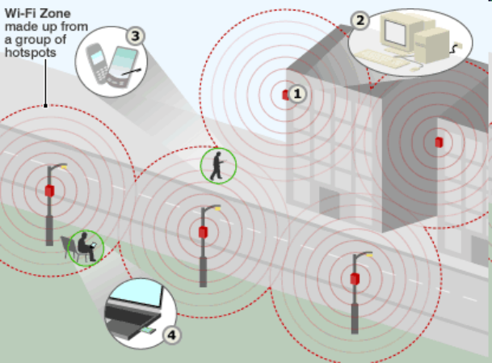
Figure 2.Wi-Fi zone made up from a group of hotspots.

In a Wi-Fi network, computers with Wi-Fi network cards connect wirelessly to a wireless router. The router is connected to the Internet by means of a modem, typically a cable or DSL modem. Any user within 100 feet of the access point can then connect to the Internet. Security is also enabled when using a Wi-Fi system. It protects the VPN and secures the web pages which the user accesses. The standard devices, embedded systems and network security make it more secure.
Communication across Wi-Fi is lot more like two-way radio communication and Wi-Fi also uses radio waves just like cell phones, televisions and radios do.
Communication takes place in the following manner and this process also works in reverse:
a. A computer’s wireless adapter translates data into radio signal and transmits it using an antenna.
b. A wireless router receives the signal, decodes it and sends the information to the Internet through a wired Ethernet connection.

Wi-Fi radios transmit at frequencies of 2.4GHz or 5GHz which is considerable higher than the frequencies used for cell phones, walkie-talkies and televisions. This higher frequency helps in carrying more data. Wi-Fi uses 802.11 networking standards, which come in several flavors [2]:
1. 802.11a: It transmits at 5 GHz and can handle up to 54 megabits of data per second. It uses orthogonal frequency-division multiplexing (OFDM), a more efficient coding technique that splits the radio signals into several sub-signals before they reach a receiver. This greatly reduces interference.
2. 802.11b: It is the slowest and least expensive standard which transmits at 2.4 GHz frequency and can handle up to 11 megabits of data per second, and it uses complementary code keying (CCK) modulation to improve speeds.
3. 802.11g: It transmits at 2.4 GHz like 802.11b, but it is faster than 802.11b because it uses the same OFDM coding technique as used by 802.11a and it can handle up to 54 megabits of data per second.
4. 802.11n: It is the newest standard that is widely available. This standard significantly improves speed and range and can achieve speeds as high as 140 megabits per second.
Following is an example of how the Wi-Fi connection has been used to build a smart car:
The Spirit of Berlin team, an AI group at Freie University Berlin has developed an iPhone app to remotely control the car. The iPhone connects to the car’s driving circuitry by a Wi-Fi network. The car’s onboard circuitry offers three types of controls: Steering wheel, Gas (Accelerator throttling), Brakes. The signals like providing the Gas or Brakes or Steering wheel are transferred from the iPhone to the Wi-Fi router. The Router then transfers these signals to the powerful computer placed inside the car, which then monitors the car accordingly. This car is said to be even more intelligent because if we just key in to the computer and say which place we want to go to, then this car, with the help of laser sensors, takes us to that place, finds a parking space and parks the car there. Therefore we do not really need an iPhone to monitor this car [7].

2.1.1 Advantages of Wi-Fi

1. Range is not limited by wires: We carry our laptop anywhere in the house and still be able to access the Internet.

2. Hotspots allow us to access the Internet at public places: Instead of having to be constricted to our home wired/wireless Local Area Network (LAN), we can now enjoy the advantages of the Internet in public places such as lobbies, cafes, universities, hotels, airports, and many other common areas.

2.1.2 Disadvantages of Wi-Fi

1. As the distance between our computer/laptop and the access point increases, the speed and the quality of Wi-Fi falters tremendously.

2. Wi-Fi connection has to be set up away from Electro Magnetic Radiating devices such as microwaves because these devices use the same frequency that 802.11g and 802.11b use (2.4GHz) and therefore results in the interference.

3. The Wired Equivalent Privacy (WEP), the common wireless encryption standard used in Wi-Fi can be easily broken even when configured accurately.

2.1.3 Future Directions

The future is set to provide greater and longer connection ranges with faster transfer speeds. Future hotspot architectures could be multihop, i.e., a network where mobile nodes reach the access point over one or more hops of an ad hoc network. In the future, we would also see better securities measures in protecting personal and confidential data's being received and sent out. With fierce competition of different companies we would see cheaper internet connection costs and choices for better services to consumers.

2.2 WiMAX

Standardization through the IEEE 802.16 specification raises the potential to:
- Stall wired broadband and make wireless the key platform of the future.
- Extend the range of Wi-Fi so that the myth of ubiquitous wireless can become a reality.
- Provide an alternative or complement to 3G.
- Provide an economically viable communications infrastructure for developing countries and mobile black spot regions in developed nations.
WiMAX addresses all the key elements that are needed to make high end wireless a reality, and which broadband wireless access (BWA) technologies have failed fully to provide – a single standard for fixed broadband access and mobility, wireless WLAN backhaul, low cost of deployment, high scalability and the support of vendors with the power to drive the standard forward rapidly.
WiMAX meaning Worldwide Interoperability for Microwave Access, is a fourth generation(4G) of wireless technology designed to enable pervasive, high-speed mobile Internet access to the widest array of devices including notebook PCs, handsets, smartphones, and consumer electronics such as gaming devices, cameras, camcorders, music players, and more. WiMAX has the potential to deliver high speed Internet access to metropolitan, sub-urban, or rural areas. The technology provides up to 10 Mbps broadband speed without the need for cables. In practical terms, WiMAX would operate similar to Wi-Fi but at higher speeds, over greater distances and for a greater number of users. WiMAX technology will allow us to connect in more places, more often, without being restricted to hotspots. When built into notebooks and mobile devices, we will be able to extend our connected experience beyond Wi-Fi. WiMAX is built for the future with advanced, efficient wireless technology that provides higher speeds than today’s wide area wireless technologies. WiMAX is developed by an industry consortium, overseen by a group called the WiMAX Forum. The WiMAX Forum certifies WiMAX equipment to ensure it meets the technology standards.

WiMAX enables the freedom and convenience that comes from having the Internet standing by where and when we need it—staying connected on the go to the people, communities, and resources that make up our lives.
WiMAX network uses an approach that is similar to that of cell phones. Coverage for a geographical area is divided into a series of overlapping areas called cells. Each cell provides coverage for users within that immediate proximity. When the user travels from one cell to another, the wireless connection is handed off from one cell to another.

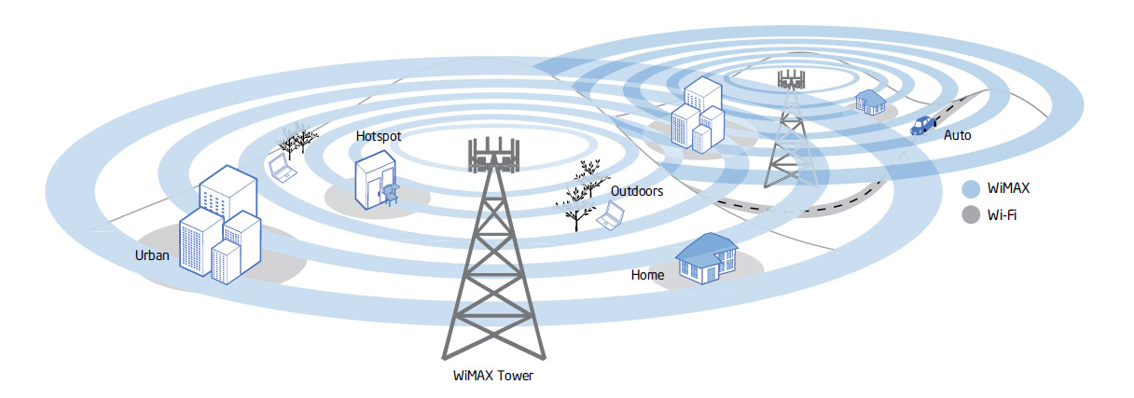
Figure 3.WiMAX blankets large areas with broadband Internet

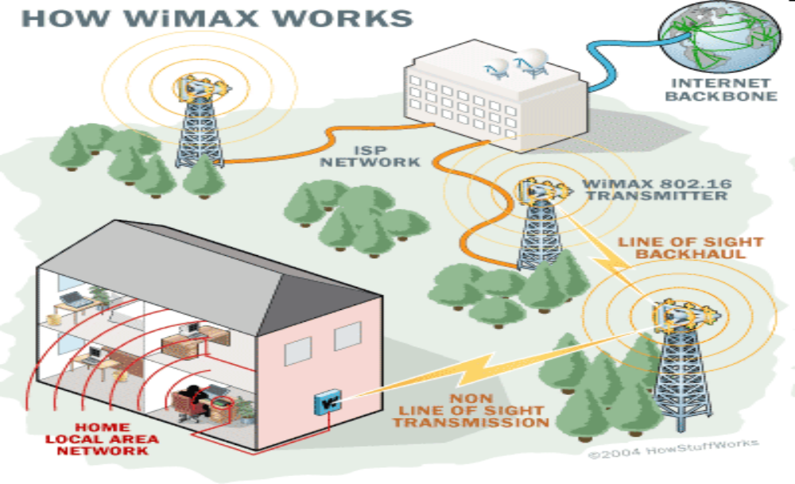
Figure 4.WiMAX

A WiMAX system consists of two parts [3]:
1. A WiMAX Base Station: Base station consists of indoor electronics and a WiMAX tower. WiMAX tower is similar in concept to a cell-phone tower. A single WiMAX tower can provide coverage to a very large area as big as 3,000 square miles (~8,000 square km). Any wireless node within the coverage area would be able to access the Internet.
2. A WiMAX receiver - The receiver and antenna could be a small box or PCMCIA card, or they could be built into a laptop the way Wi-Fi access is today.
A WiMAX tower station can connect directly to the Internet using a high-bandwidth, wired connection. It can also connect to another WiMAX tower using a line-of-sight, microwave link. This connection to a second tower (often referred to as a backhaul), along with the ability of a single tower to cover up to 3,000 square miles, is what allows WiMAX to provide coverage to remote rural areas.
WiMAX can provide two forms of wireless service:
Non-line-of-sight: This service is similar to the WiFi service. In this mode, WiMAX uses a lower frequency range of 2 GHz to 11 GHz. Lower-wavelength transmissions are not as easily disrupted by physical obstructions. They are better able to diffract, or bend, around obstacles.
Line-of-sight: The line-of-sight connection is stronger and more stable, so it is able to send a lot of data with fewer errors. Line-of-sight transmissions use higher frequencies, with ranges reaching a possible of 66 GHz. At higher frequencies, there is less interference and lots more bandwidth.
2.2.1 Advantages of WiMAX over Wi-Fi
a. Speed: The fastest WiFi connection can transmit up to 54 megabits per second under optimal conditions. WiMAX should be able to handle up to 70 megabits per second.
b. Distance: WiFi's range is about 100 feet (30 m). WiMAX will blanket a radius of 30 miles (50 km) with wireless access.
c. Cost: Instead of putting in a bunch of WiFi hot spots that cover a few hundred square yards, a city could pay for one WiMAX base station and cover an entire financial district.
2.2.2 Disadvantages of WiMAX
a. Bandwidth shared among users: WiMAX distributes the bandwidth among users. This means, we will experience slow down when there are more uses in the base.

b. Speed decrease over large distance: Because of bit rate errors happening at large distance, WiMAX system is forced to use lower bit rates at these distances. This means less data transfer rate.

c. Interference may affect connectivity: As the WiMAX uses radio waves, it is susceptible to interference caused by other equipments.
d. Rain can affect connectivity: As fixed WiMAX requires line-of-sight radio link, heavy rain can disrupt the entire link.
e. Strong electrical support: WiMAX is very power intensive technology and requires strong electrical support.
2.2.3 Future Directions
A future addition to the WiMAX standard will add full mesh networking capability. Mesh networking is a way to route data, voice and instructions between nodes specifically for wireless and wired networks. An important feature is that this kind of network can still operate even when a node breaks down or a connection goes bad and this can lead to great reliability. A mesh network effectively extends a network by sharing access to higher cost network infrastructure. This will lead to a widespread adoption of WiMAX technologies in many fields and applications. Future directions of WiMAX also include an interesting potential for interoperability of WiMAX with cellular networks. WiMAX antennas can share a cell tower without compromising the function of cellular already in place [4].
2.3 MiFi
MiFi is a small, portable wireless device which creates a personal cloud of high-speed Internet connectivity and delivers wireless 3G data network access to multiple users in a small area.
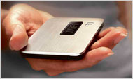
Figure 5.Novatel's MiFi, a 3G Wi-Fi router
The Intelligent Mobile Hotspot provides access to up to five Wi-Fi enabled devices, including notebooks, netbooks, MP3 players, smartphones, cameras, PDAs, portable gaming systems and more. It has one power button, one status light and a swappable battery that looks like the one in a cell phone. The battery lasts for about four hours of use and 40 hours of standby on a charge, according to Verizon Wireless. If we turn on the MiFi and wait for 30 seconds, it provides a personal, portable, powerful, password-protected wireless hot spot. The MiFi gets its Internet signal the same way those cellular modems do. In essence, the MiFi converts that cellular Internet signal into an umbrella of Wi-Fi coverage that up to five people can share. The MiFi is remarkable for its tiny size, its sleek good looks, its 30-foot range and the fact that it’s cordless and rechargeable [6].
2.3.1 Advantages of MiFi
a. Connection sharing: MiFi allows us to use the same connection to get online with any WiFi-enabled device including notebooks, MP3 players, smartphones, cameras, PDAs, portable gaming systems and more.
b. Cost savings: MiFi offers pay as you go plan which makes MiFi a great choice for families who need to connect multiple devices but do not want to pay out for internet access that they may not use. It also means that MiFi is a cost-effective solution for students who are living in a shared house.
c. Portability: MiFis do not need to be connected to the device for which they are providing an internet service. From wherever we are in the coverage area, it detects the Wireless network and allows us to access a reliable broadband connection.
d. Fast set-up: Unlike others, MiFis do not require users to install any software on their Wi-Fi enabled device [5].
2.3.2 Disadvantages of Mi-Fi
a. MiFi unit price: The cost of buying a MiFi with some providers is significantly higher. However, price of MiFi is expected to fall as they become more popular.
b. Sharers can soon run through their allowance: Allowing more than one person to use a connection makes it more likely that user will reach his/her monthly download limit much faster.
3. Conclusion
Technology seems inevitable and impossible to survive without. They allow us to do things faster and better than we could if we did not have them. Wi-Fi “hot spots” are becoming more popular throughout urban environments. Wi-Fi technologies have helped drive down the price of broadband internet access to urban and rural areas. It has also helped increase profits for Internet Service Providers by helping minimize monthly recurring cost of back haul circuits. WiMax technologies help extend the reach of broadband service to outlying areas. WiMax increases the quality of service delivered to end users by its exceptional speed and distance coverage. WiMax will lead to an “internet anywhere” environment much like that of the cellular phone industry has been documented. Mi-Fi is new and interesting technology which is becoming popular nowadays because of its ability to connect up to five devices at the same time.
As the evolution of wireless technologies continues to advance, the progression of mobile services will continue to evolve into ever-richer, more compelling mobile and converged services.
4. References
[1] http://www.isoc.org/internet/history/brief.shtml
[2]http://computer.howstuffworks.com/wireless-network.htm
[3] http://computer.howstuffworks.com/wimax.htm
[4] http://www.knowledgeboard.com/item/2701
[5]http://www.top10-broadband.co.uk/compare/mifi_mobile_broadband/
[6]http://skattertech.com/2009/10/verizon-wireless-mifi-2200-review/
[7]http://dailymobile.se/2009/10/13/idriver-and-spirit-of-berlin-iphone-remote-controlled-car/
[8]http://usatoday.jiwire.com/broadband-wireless-future-wimax-future.htm

